Supplementary Figure S1. Distribution of filtered HLA-I positive binding peptides by length and allele type.
A. The overall count distribution of positive peptides ranging from 5 to 20 amino acids (AA) in length within the curated testing dataset. B-F. The count distribution of positive peptides across the 44 selected HLA-I alleles for specific peptide lengths: 8-mer (B), 9-mer (C), 10-mer (D), 11-mer (E), and 12-mer (F). A dashed red horizontal line indicates a minimum sample size threshold of 20 peptides. For each length stratum, HLA alleles failing to meet this threshold (< 20 positive peptides) are explicitly highlighted with red text on the x-axis and colored in grey, whereas alleles meeting the threshold are colored in blue.
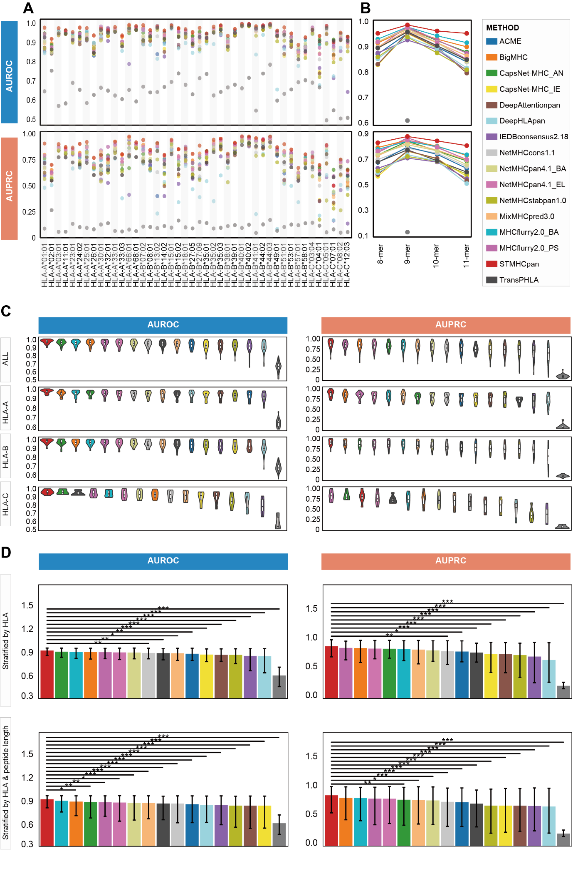
Supplementary Figure S2. Detailed AUROC and AUPRC performance evaluation of HLA-I peptide binding predictors.
A. Scatter plots illustrating the AUROC (top) and AUPRC (bottom) values for individual HLA-I alleles across all evaluated predictors. B. Line plots displaying the trend of mean AUROC (top) and AUPRC (bottom) values evaluated across different peptide lengths. C. Violin plots overlaid with box-and-whisker plots depicting the distribution of AUROC (left) and AUPRC (right) scores. The distributions are presented for all alleles combined (top) and stratified by specific HLA loci (HLA-A, HLA-B, and HLA-C, respectively). D. Bar plots comparing the mean AUROC (left) and AUPRC (right) with their 95% confidence intervals (95% CIs). The upper panels display metrics evaluated by HLA-I allele (n = 44), while the lower panels show metrics calculated for individual conditions considering both allele and peptide length (n = 176). Statistical significance for inter-method comparisons (the top-performing model versus others) was assessed using pairwise Wilcoxon tests with Bonferroni correction (*P < 0.05, **P < 0.01, ***P < 0.001).

Supplementary Figure S3. Optimization of decision thresholds based on the comprehensive performance score for individual predictors.
Line plots illustrating the trajectory of the comprehensive score across tool-specific candidate thresholds for the evaluated HLA-I peptide binding predictors. For each predictor, a solid black line traces the comprehensive score across the full range of candidate thresholds. A red dot highlights the peak comprehensive score, with a corresponding vertical dotted red line pinpointing the exact optimal threshold value. Additionally, a horizontal dashed red line designates the 90% stability zone (defined as 90% of the maximum comprehensive score), highlighting the threshold range within which each model maintains robust predictive performance.

Supplementary Figure S4. Model performance degradation across varying data imbalance scenarios.
Cleveland dot plots illustrating the variation in seven key performance metrics (accuracy, sensitivity, specificity, precision, F1-score, MCC, and the comprehensive score) across four different positive-to-negative dataset ratios (1:1, 1:4, 1:9, and 1:99). Each colored dot represents the metric value for a specific predictor under a given dataset ratio. Vertical grey lines connect the points for each individual tool, visually highlighting the range of metric variation and performance stability across different levels of data imbalance. The prediction models on the x-axis are ranked in descending order based on their comprehensive score achieved in the 1:9 ratio scenario. Abbreviation: MCC, Matthews correlation coefficient.
Supplementary Figure S5. Position and residue specificity of 11 HLA-I alleles.
Position and residue specificity for 8-, 9-, 10-, and 11-mer peptides of the following HLA-I alleles: A. HLA-B*07:02,B. HLA-C*08:02,C. HLA-A*33:01, D. HLA-A*33:03, E. HLA-B*35:01, F. HLA-B*35:02, G. HLA-B*35:03, H. HLA-B*40:01, I. HLA-B*40:02, J. HLA-B*44:02, and K. HLA-B*44:03.

Supplementary Figure S6. Validity of test dataset for explainable AI.
A-C. Binding motifs for each selected HLA-I allele in the test dataset. D-F. FN ratio of each predictor in the test dataset compared to the original dataset. A lower FN ratio indicates better prediction performance. FN, False negative.

Supplementary Figure S7. Correlation between positional information content and explainable AI attribution scores.
Scatter plots illustrating the relationship between the Position Weight Matrix (PWM) information content (measured in bits) and the mean absolute attribution scores derived from SHAP (A) and LIME (B) across various HLA-I peptide binding predictors. The analysis is based on a curated testing dataset consisting of 100 selected 9-mer peptides for each of the three target alleles (HLA-A*02:01, HLA-B*15:02, and HLA-C*05:01). Each point represents a specific amino acid position within the peptide, dynamically colored by its corresponding HLA allele. A dashed black line in each facet represents the linear regression fit. Statistical dependence between the ground-truth motif information content and the XAI-derived feature importance was evaluated using Spearman's rank correlation, with the correlation coefficient (R) and significance level (p-value) annotated for each predictor. Abbreviations: PWM, position weight matrix; XAI, explainable artificial intelligence; SHAP, SHapley Additive exPlanations; LIME, Local Interpretable Model-agnostic Explanations.

Supplementary Figure S8. Global agreement and peptide-level discrepancies between SHAP and LIME explainability methods.
A. Scatter plots illustrating the global correlation between SHAP and LIME positional attribution scores for 9-mer peptides across all evaluated HLA-I binding predictors. Each point represents the paired SHAP (x-axis) and LIME (y-axis) scores for a specific amino acid residue. A dashed red line in each facet represents the linear regression fit. The overall agreement for each predictor is quantified and annotated using Spearman's rank correlation coefficient. B. Line plots highlighting eight specific peptide-level examples demonstrating the strongest disagreement (i.e., the lowest Spearman correlation) between SHAP and LIME attributions. The positional attribution scores are plotted across the 9 amino acid positions, with red and blue lines representing SHAP and LIME scores, respectively. These examples showcase instances of divergent positional importance interpretations (e.g., conflicting attributions at the P9 anchor position) between the two explainable AI methods. Abbreviations: XAI, explainable artificial intelligence; SHAP, SHapley Additive exPlanations; LIME, Local Interpretable Model-agnostic Explanations.
Supplementary Figure S9. Cross-validation of positional importance using physical structural stability and explainable AI attributions.
A. The structural stability contribution of each amino acid position (P1 to P9) for three representative peptide-HLA-I complexes (HLA-A*02:01 with NAAERRGPL, HLA-B*15:02 with HVEKLARTL, and HLA-C*05:01 with SLIARLERL). Peptide-MHC structures were modeled using APE-Gen2.0, and the binding free energy changes (InterDDG, or ΔΔG) were calculated via computational alanine scanning using BAlaS. Green bars indicate the mean ΔΔG across all simulated structural conformations, with error bars representing the standard deviation (SD). B. The corresponding explainable AI (XAI) positional attribution scores for the same three representative peptides. Orange and blue bars represent the mean SHAP and LIME scores, respectively, calculated across all evaluated prediction tools. Error bars denote the SD of the attribution scores among the different predictors, reflecting the cross-tool consensus on positional importance. Abbreviations: XAI, explainable artificial intelligence; SHAP, SHapley Additive exPlanations; LIME, Local Interpretable Model-agnostic Explanations; ΔΔG, change in Gibbs free energy; SD, standard deviation.
Supplementary Figure S10. LIME values of HLA-I peptide binding predictors.
A-C. Median LIME values generated by eight predictors across 100 peptides for each allele. D-F. LIME values for each residue of the ligand peptide and corresponding binary binding results across predictors. Abbreviations: LIME, Local Interpretable Model-agnostic Explanations.

Supplementary Figure S11. Correlation between biophysical structural stability and explainable AI attribution scores.
Scatter plots demonstrating the relationship between the computed mean binding free energy change (ΔΔG) and attribution scores from (A) SHAP and (B) LIME across various HLA-I peptide binding predictors. Each point represents an individual amino acid residue from the three representative peptide-HLA complexes, color-coded by the specific peptide sequence. A dashed black line in each facet represents the linear regression fit. The statistical dependence between the biophysical ΔΔG (kJ/mol) and the XAI attribution scores was evaluated using Spearman's rank correlation, with the correlation coefficient (R) and significance level (p-value) annotated for each predictor. Abbreviations: XAI, explainable artificial intelligence; SHAP, SHapley Additive exPlanations; LIME, Local Interpretable Model-agnostic Explanations; ΔΔG, change in Gibbs free energy.
Supplementary Figure S12. Distribution of explainable AI attribution scores stratified by biophysical energetic importance.
Boxplots comparing the distribution of (A) SHAP and (B) LIME attribution scores between biophysically critical and non-critical amino acid residues across different predictors. Residues were classified into two categories based on their computed mean ΔΔG: Critical (ΔΔG ≥ 4.184 kJ/mol, depicted in red) and Non-Critical (ΔΔG < 4.184 kJ/mol, depicted in blue). Individual data points are overlaid as jitter to show the underlying distribution. Statistical significance between the two energetic importance groups was calculated using the two-sided Wilcoxon rank-sum test, with exact p-values displayed for each model. Abbreviations: XAI, explainable artificial intelligence; SHAP, SHapley Additive exPlanations; LIME, Local Interpretable Model-agnostic Explanations; ΔΔG, change in Gibbs free energy.

